Using Insurance.csv attempt the following
- Using reference line, display average property claim for each authorised contacted.
Ans:
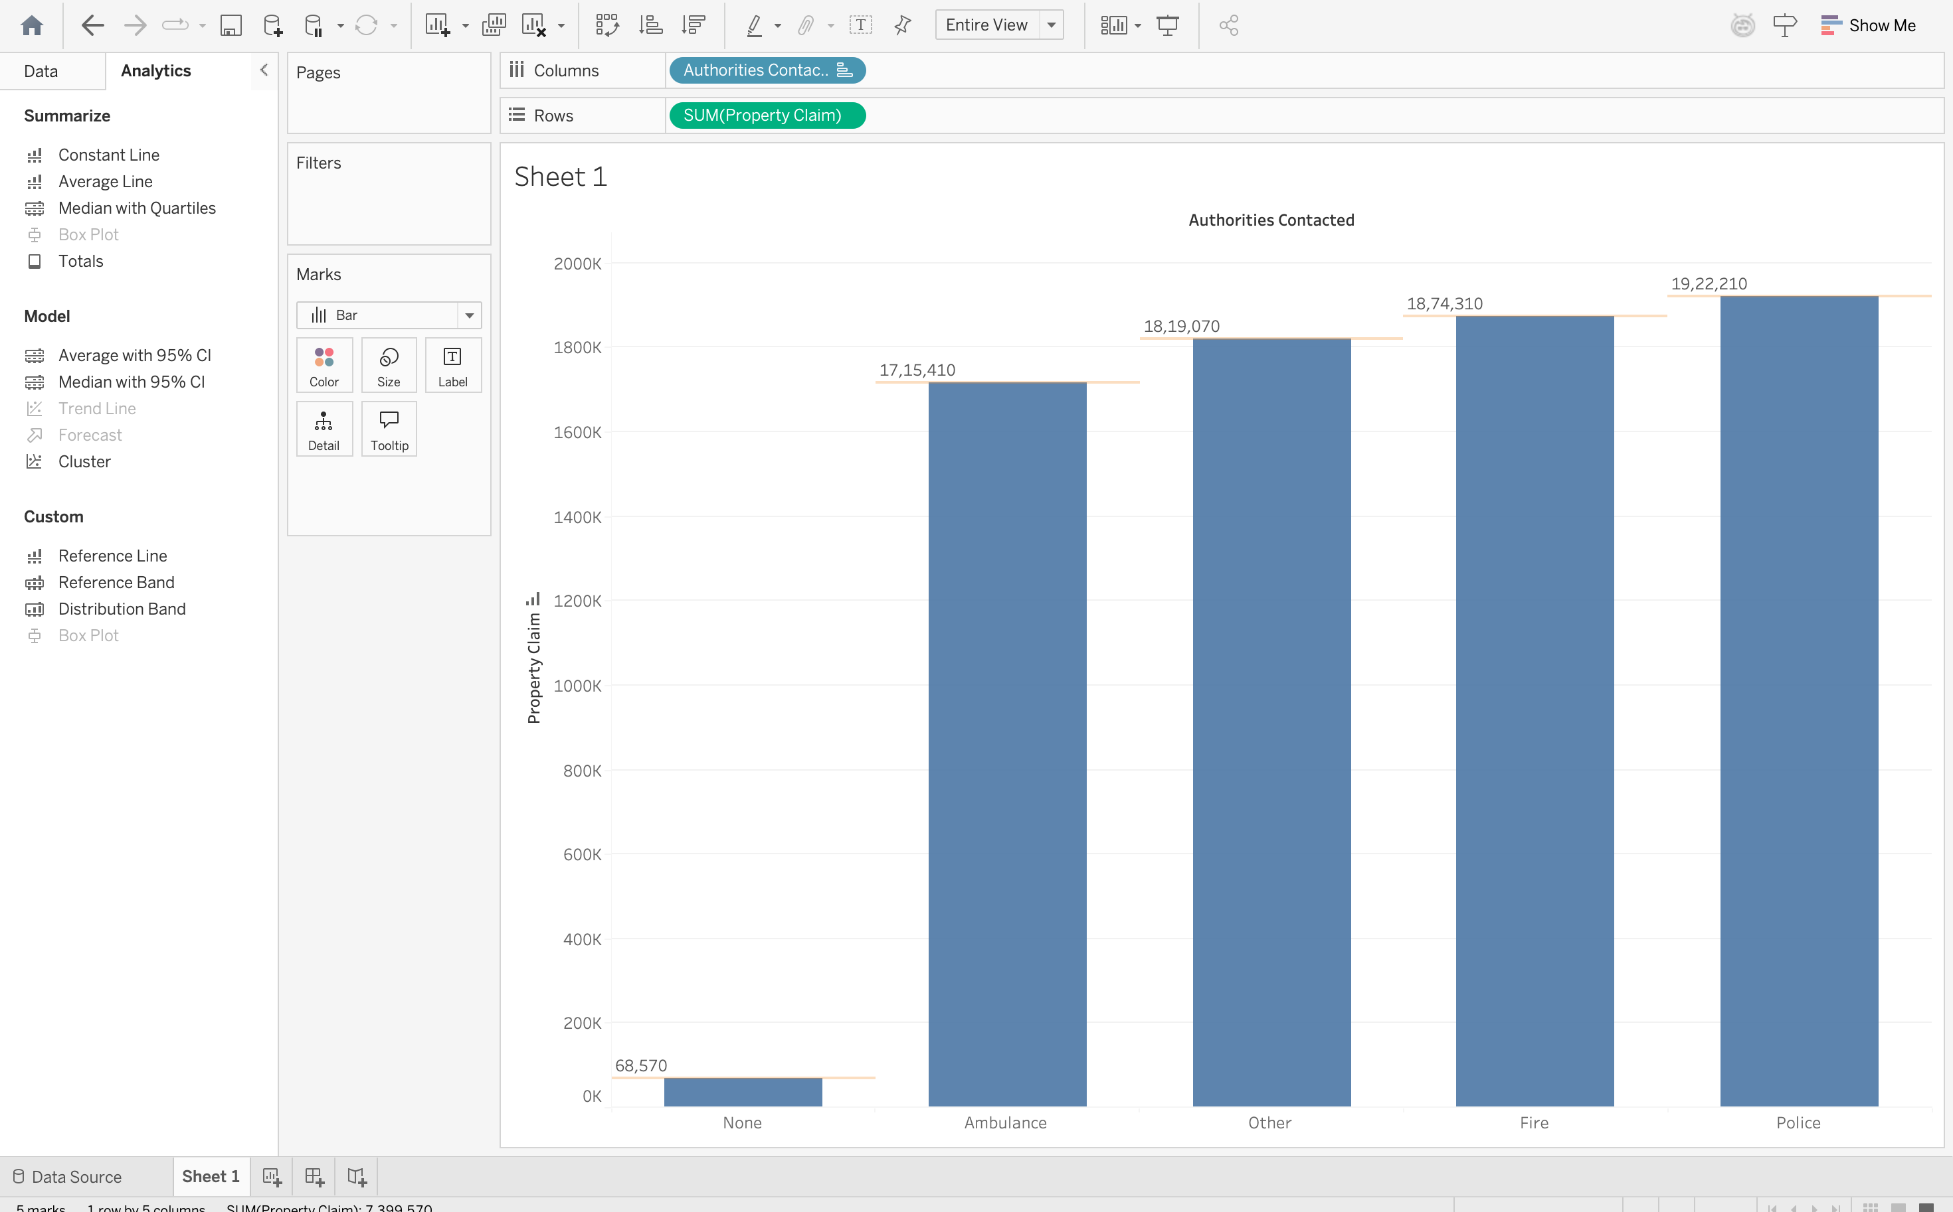

- Using box and whisker plot, display make wise vehicle claim for each policy number.
Ans:
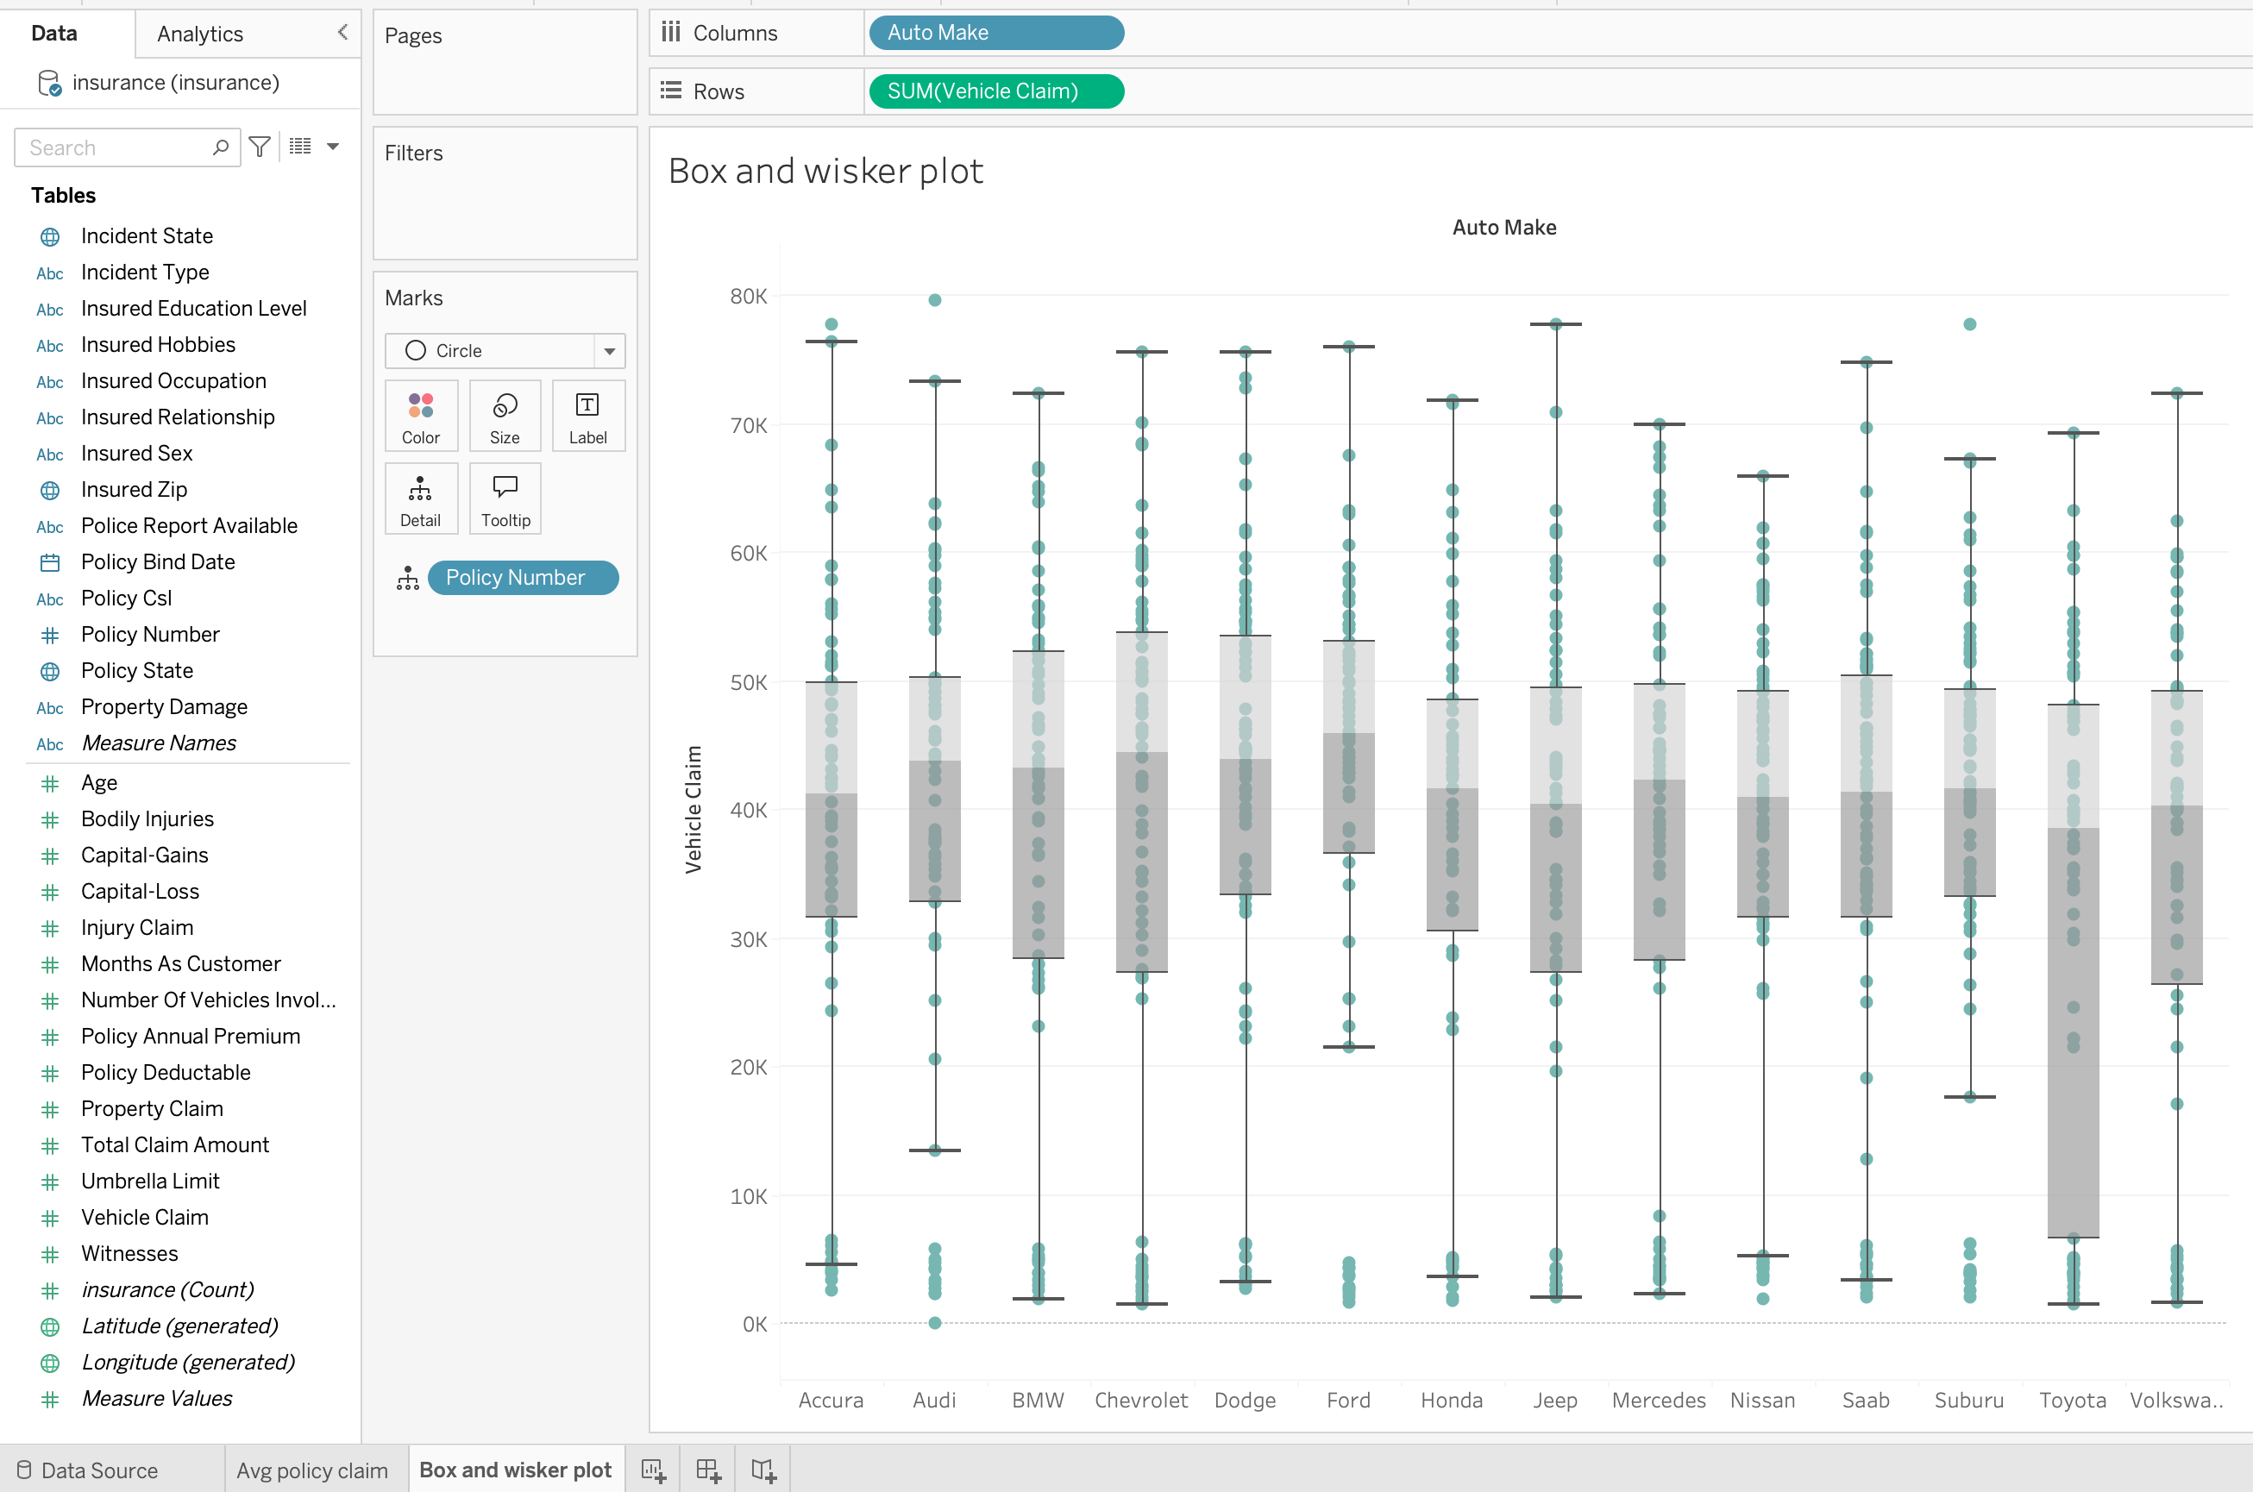

- Forecast the total claim amount for year 2015,2016,2017,2018,2019.
Ans:
